

Morgan Kendall Poole - March 2013

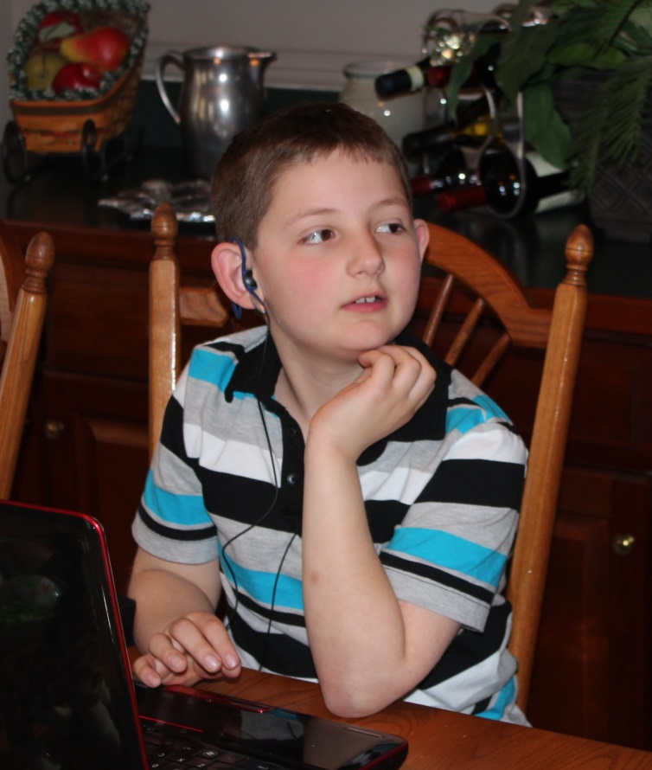

Elliott Dmitri Poole, son of Morgan Kendall Poole - March 2013